**Abstract**

This project involves building an attendance system which utilizes facial recognition to mark the presence, time-in, and time-out of employees. It covers areas such as facial detection, alignment, and recognition, along with the development of a web application to cater to various use cases of the system such as registration of new student, addition of photos to the training dataset, viewing attendance reports, etc. This project intends to serve as an efficient substitute for traditional manual attendance systems. It can be used in corporate offices and organizations where security is essential.

**Contents**

**1 Introduction**  2

1.1 Document Purpose 3

1.2 Product Scope 3

1.3 Intended Audience and Document Overview 3

1.4 Definitions, Acronyms and Abbreviations 4

1.5 Document Conventions 4

1.6 References and Acknowledgments 4

**2 Overall Description**  5

2.1 Product Perspective 5

2.2 Product Functionality 5

2.3 Users and Characteristics 5

2.3.1 Functionalities of Admin 5

2.3.2 Functionalities of Student 6

2.4 Operating Environment 6

2.5 Design and Implementation Constraints 6

2.6 User Documentation 6

2.7 Assumptions and Dependencies 7

**3 Specific Requirements**  8

3.1 External Interface Requirements: 8

3.1.1 USER INTERFACE 8

3.1.2 Hardware Interfaces 11

3.1.3 Software Interfaces 11

3.1.4 Communications Interfaces 12

3.2 Functional Requirements 12

3.2.1 Registration and Login Module 12

3.2.2 Manage Attendance Details 12

3.2.3 Manage Employee Details 12

3.2.4 Manage Registration and Login 13

3.2.5 Manage Attendance Details 13

3.2.6 Manage Employee Details 14

3.3 Behaviour Requirements 15

3.3.1 Use Case View 15

**4 Other Non-Functional Requirements**  15

4.1 Performance Requirements 15

4.2 Requirements and Security Requirements 16

4.3 Software Quality Attributes 16

4.3.1 Adaptability 16

4.3.2 Portability 16

4.3.3 Availability 16

4.3.4 Scalability 16

4.3.5 Correctness 16

4.3.6 Flexibility 17

4.3.7 Robustness 17

4.3.8 Test-ability 17

4.3.9 Usability 17

**5 ADVANTAGES**  18

**6 DISADVANTAGE**  18

**7 CONCLUSION AND FUTURE SCOPE**  19

**8 Appendix A - Data Dictionary**  19

**Chapter 1**

# Introduction

This project involves building an attendance system which utilizes facial recognition to mark the presence, time-in, and time-out of student. It covers areas such as facial detection, alignment, and recognition, along with the development of a web application to cater to various use cases of the system such as registration of new employees, addition of photos to the training data set, viewing attendance reports, etc. This project intends to serve as an efficient substitute for traditional manual attendance systems. It can be used in corporate offices and organizations where security is essential. Face detection and recognition is often referred to as, analyses characteristics of a person’s face image input through a camera. It measures overall facial structure, distances between eyes, nose and mouth. The software first captures an image of all the authorized persons and stores the information into database. The system then stores the image by mapping it into a face coordinate structure. Next time whenever the registered

## 1.1 Document Purpose

The purpose of this SRS document is to specify software requirements of the Attendance Management System Using Face Recognition. It is intended to be a complete specification of what functionality the Attendance Management System provides.

This project aims to automate the traditional attendance system where the attendance is marked manually. It also enables an organization to maintain its records like in-time, out time, break time and attendance digitally. Digitization of the system would also help in better visualization of the data using graphs to display the no. of employees present today, total work hours of each employee and their break time. Its added features serve as an efficient upgrade and replacement over the traditional attendance system.

## 1.2 Product Scope

Facial recognition is becoming more prominent in out society. It has made major progress in the field of security. It is a very effective tool that can help low enforcers to recognize criminals and software companies are leveraging the technology to help users access the technology. This technology can be further developed to be used in other avenues such as ATM, accessing confidential files, or other sensitive materials.

It is a type of bio metric software application that can identify a specific individual in a digital image by analyzing and comparing patterns. Facial recognition systems are commonly used for security purposes but are increasingly being used in a variety of other applications.

This project servers as a foundation for future projects based on facial detection and recognition. This project also covers web development and database management with a user-friendly UI. Using this system any corporate offices, school and organization can replace their traditional way of maintaining attendance of the employees and can also generate their availability(presence) report throughout the month.

## 1.3 Intended Audience and Document Overview

This document is intended for developers, project managers, marketing stuff, users, testers and documentation writers of the system. Preference to read the document is in the sequence of table of contents only. Document is organized in a manner to understand the need and implementation details of the system.

## 1.4 Definitions, Acronyms and Abbreviations

**ER** stand for Entity Relationship Diagram

**SRS** stand for Software Requirement Specification

**ASFR** stand for Attendance System Using Face Recognition

## 1.5 Document Conventions

No specific user document conventions are used this time. All the sections and points are written in simpler words with utmost clarity.

## 1.6 References and Acknowledgments

This document refers to the IEEE standards SRS.

**Chapter 2**

# Overall Description

## 2.1 Product Perspective

The proposed Attendance Management System will take care of the student attendance in any organization at any point of time. The system can keep a track of the student’s presence, time-in and time-out. It can automatically generate reports and graphs of their availability which can be monitored by the higher authority of the respective management of schools.

## 2.2 Product Functionality

The main objective of this project is to reduce the manual work.

The system is capable of managing student’s presence, time-in and time-out. It can generate reports of their availability.

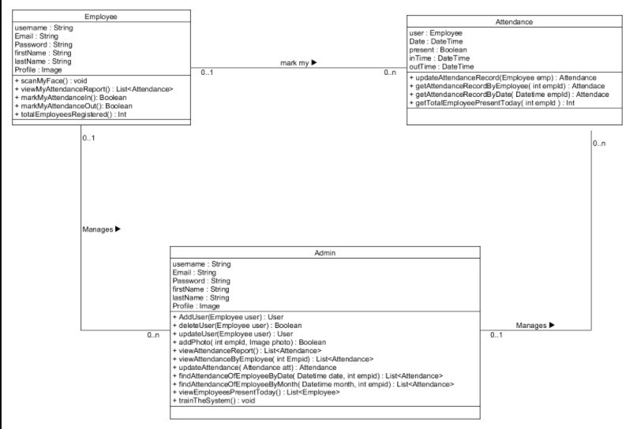

FIGURE-CLASS DIAGRAM

## 2.3 Users and Characteristics

We have 2 types of users of the system

Student

Admin

### 2.3.1 Functionalities of Admin

Following functionalities can be performed by the admin:

Login.

Register new student to the system.

Add employees photos to the training data set.

Train the model.

View attendance report of all employees. Attendance can be filtered by date or student.

### 2.3.2 Functionalities of Student

Following functionalities can be performed by the student:

Login.

Mark his/her time-in and time-out by scanning their face.

View attendance report of self.

## 2.4 Operating Environment

The server-side components of the system can have running windows or Linux OS with the necessary library supports of the system. The client-side components of the software system must operate within common web browser environments using Secure Sockets Layer (SSL) / Transport Layer Security (TLS) cryptographic protocols at a minimum encryption level of 128 bits.

The minimum set of browsers that must be supported is

Google Chrome 44+

Mozilla Firefox

## 2.5 Design and Implementation Constraints

As the system is using face recognition feature to identify each employee of the organization, it must be able to identify each of them individually. According to this, system must be capable to mark their presence for the day and it should convey the same message to the student as well.

## 2.6 User Documentation

No specific user documentation is considered this time

## 2.7 Assumptions and Dependencies

No specific assumptions or dependencies are considered at this time.

**Chapter 3**

# Specific Requirements

## 3.1 External Interface Requirements:

The following sections will introduce the numerous requirements of the system from the point of view of different users and will introduce a number of decisions that have been made regarding implementation.

### 3.1.1 USER INTERFACE

#### Mark In Attendance

This view represents the whole view to the user.The user can marks his/her attendance.The user can log in to his personal account.



Figure 3.1: Mark In Attendance

#### Mark Out Attendance

When the particular user has marked his attendance,he can log out of the attendance page.



Figure 3.2: Mark Out Attendance

#### Login

There is a login option being viewed in the main welcome page.

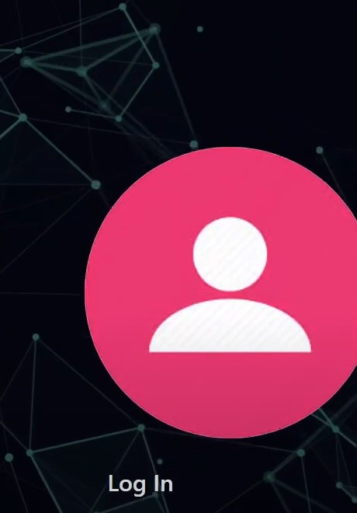

Figure 3.3: Login

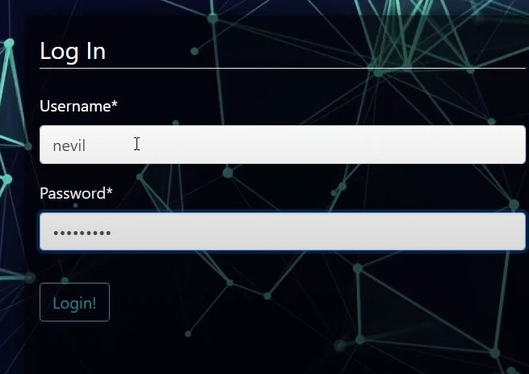

Figure 3.4: Login Credentials

#### Login Credentials

When the user click on the login button viewed in the welcome page,the user go to the page where he/she has to put the login credentials.

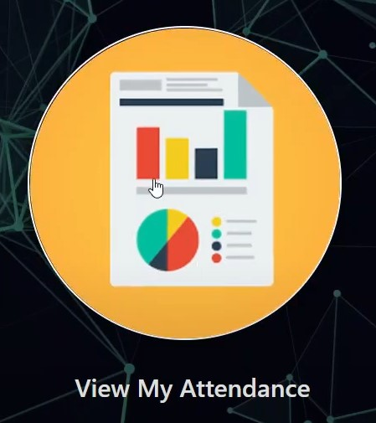

Figure 3.5: Attendance viewing

#### View the Attendance

If the user write right credentials,he/she will be granted the access to view his/her attendane but if he fails to enter right credentials,he/she will be granted no access.

### 3.1.2 Hardware Interfaces

Following are the hardware interfaces of the system:

I3 processor-based computer or higher.

Memory: 3GB RAM

Hard drive.

Working Web camera with clear image.

### 3.1.3 Software Interfaces

Following are the software interfaces of the system:

Windows or Linux Operating System

Client-side Browser Support

Server-side Django + SQLITE Database Support.

### 3.1.4 Communications Interfaces

Following are the software interfaces of the system:

Communication Standard: HTTPS

Network Server: Localhost

Chrome / Mozilla Web Browser

## 3.2 Functional Requirements

The features of the system are mainly divided into 3 modules.

### 3.2.1 Registration and Login Module

This module mainly deals with the functionalities related to the registration of any new employee to the organization, Log into the system and managing employee’s profile details. Using features provided by this module admin can register new employee to the system and admin / employee both can log into the system using their credentials.

### 3.2.2 Manage Attendance Details

This module mainly deals with the features related to the employee’s attendance. Using this employee can mark their presence, time-in and time-out in the system. Admin can see the availability report of each employee, employee can see his/her attendance report along with some possible filters such as filter by employee and filter by date.

### 3.2.3 Manage Employee Details

This module mainly deals with the features related to the employee’s profile. Using this admin can add a photo of the newly registered employee during registration. Admin can also command the system explicitly to train the model and system will make necessary calculation and will generate some data which will be used internally to identify each employee uniquely.

### 3.2.4 Manage Registration and Login

##### Register new employee

Description: Admin can register new Input: Employee Details Output: success message displaying the user has been created.

##### Log-In to the system

Input: User credentials Output: If the credentials are correct, user will be redirected to the dashboard of the system Exception Flow: If the entered credentials are incorrect then user will be redirected to the login page again displaying an error message.

### 3.2.5 Manage Attendance Details

##### Mark your attendance-in

Input: User will scan his/her face using the external web camera. Output: system will identify the user uniquely and will mark his/her in-time to the database. The same success message will be transmitted to the user.

##### Mark your attendance-out

Input: User will scan his/her face using the external web camera. Output: system will identify the user uniquely and will mark his/her out-time to the database. The same success message will be transmitted to the user.

##### View my attendance report

Description: Employee may often need to see his / her attendance record throughout the month or year. Using this feature one can see his / her attendance record till the date. Input: User selection Output: Statistical analytics of the particular employee who is currently logged into the system will be displayed.

##### View employee’s attendance report

Description: This feature is for admin. Admin can monitor the availability of each employee till the date. i.e., how many employees are present today out of total employees etc. can be monitored. Input: user selection Output: Attendance record of each employee including how many employees are present today out of total along with the availability graph.

### 3.2.6 Manage Employee Details

##### Add photo of the employee

Description: Admin only can access this feature. Admin can add a photo of an employee during the registration process. Input: Username of an employee Output: Success message record has been added. Process: System will process an image and will generate necessary system data to identify each employee uniquely.

##### Train the system

Input: user selection Output: system will process all the available records of the employees and will generate necessary system data to identify each employee uniquely.

## 3.3 Behaviour Requirements

### 3.3.1 User Case View

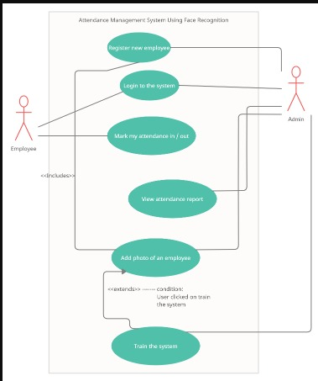

FIGURE-USER CASE DIAGRAM

**Chapter 4**

# Other Non-Functional Requirements

## 4.1 Performance Requirements

Some Performance requirements identified is listed below:

performance of the system should be fast and accurate.

The system should be able to handle large amount of data. Thus, it should accommodate high details without any fault.

There are no other specific performance requirements that will affect development.

## 4.2 Requirements and Security Requirements

As a part of the safety requirement, we prefer to keep a backup of the system generated data in any external device. Utilize certain cryptographic technique Specific log or history data sets.

Certain functions to different modules.

Restrict communications between some areas of the program

## 4.3 Software Quality Attributes

### 4.3.1 Adaptability

There can be a change in the information stored in the database.

### 4.3.2 Portability

The system is developed for secured purpose, so it is can’t be portable. .

### 4.3.3 Availability

This system will available only until the system on which it is install,running. So it totally depends on the systems and functional requirements.The system is up and running for most of the time and server is not down

### 4.3.4 Scalability

Scalability is applicable. Since we can use large database to store the information of the user and we are using 10 employees database.

### 4.3.5 Correctness

The techniques for capturing of picture must work accurately to build proper attendance data.

### 4.3.6 Flexibility

If need arises in the future, software can be modified to change the requirements and can include employee as well . Current version can be used in the future versions with more functionality added.

### 4.3.7 Robustness

Software must have checks to ensure that valid data items are entered.

### 4.3.8 Test-ability

All the requirements are fulfilled, response time is low, and all functions are working perfectly.

### 4.3.9 Usability

Interface of the software must be easy to use. It would not be complex since admin and user have a view, so interface should be simple.

**Chapter 5**

# ADVANTAGES

The software can be used for security purposes in organizations and in secured zones.

The software stores the faces that are detected and automatically marks attendance.

The system is convenient and secure for the users.

It saves their time and efforts.

**Chapter 6**

# DISADVANTAGE

It can only detect face from a limited distance

**Chapter 7**

# CONCLUSION AND FUTURE SCOPE

We come to realize that there are extensive variety of strategies, for example, bio metric, RFID based and so forth which are time consuming and nonefficient. So to overcome, this above framework is the better and reliable solution from every perceptive of time and security. In this way we have accomplished to add to a reliable and effective participation framework to distinguish faces in classroom and recognize the faces accurately to mark the attendance. This method is secure enough, reliable and available for use. No need for specialized hardware for installing the system in the classroom. It can be constructed using a camera and computer. There is a need to use some algorithms that can recognize the faces to improve the system.In this system we have implemented an attendance system for a lecture, section or laboratory by which lecturer or teaching assistant an record student’s attendance. It saves time and effort, especially if it is a lecture with huge number of employees.

**Chapter 8**

# Appendix A - Data Dictionary

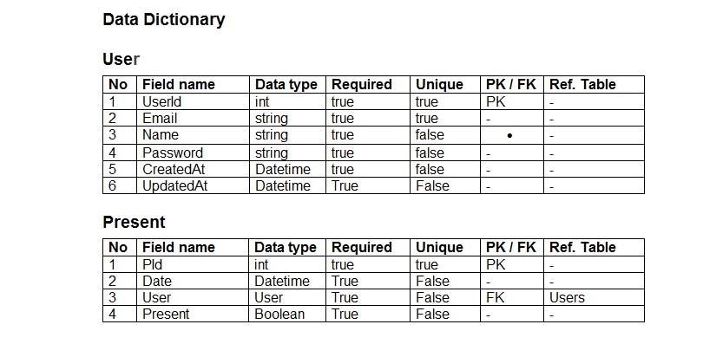

Figure 8.1: Data Dictionary Appendix

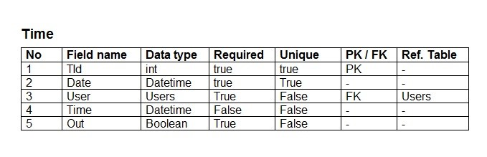

Figure 8.2: Database